http://www.theguardian.com/books/2011/aug/21/tyranny-choice-renata-selecl-review

The Tyranny of Choice by Renata Salecl – review
Do you really want to help yourself? Well, avoid self-help books, says the author of this powerful attack on consumer society
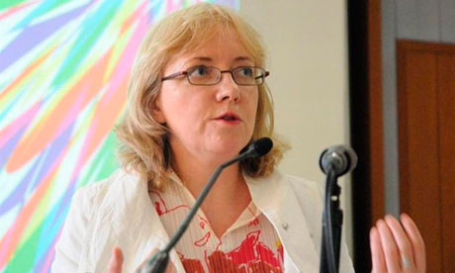

Renata Salecl: 'The idea of choosing who we want to be and the imperative to "become yourself" have begun to work against us.'
Several years ago, an American magazine editor named Jennifer Niesslein decided to iron out all the imperfections in her life. Using only the advice contained in a stack of self-help books, she set about cleaning her home, losing weight, becoming a better partner and parent and generally cultivating a more serene approach to existence. After two years of trying, she found that she was less contented, not more, and started suffering from panic attacks.
The Tyranny of Choice, in which this anecdote is recounted, has the outward appearance of a self-help manual. It is written in clear, user-friendly prose, conveniently subdivided every few pages by topic and it's short enough to be read in one sitting. It resorts to the odd generalisation to keep its argument on track. But that's where the similarities end. Salecl, a Slovenian sociologist, rubbishes the idea that a set of tips in a book, let alone a whole marketplace of books offering radically conflicting tips, can make us happier. The author casts an eye over the culture that has given rise to self-help books (they existed as early as the 17th century but their time is very much now) and points a finger at the ideology of choice, which, she believes, is at the root of modern discontent, and the industry that has grown up around it. "The idea of choosing who we want to be and the imperative to 'become yourself' have begun to work against us, making us more anxious and more acquisitive rather than giving us more freedom," she writes.
In a society geared towards the individual, and dominated by consumerism and celebrity, we are constantly encouraged to choose a better life for ourselves. The weight of each choice and the super-abundance of options can cause crippling anxiety and we defer to others to make the right choices for us. When we do get what we want, fulfilment is swiftly replaced by dissatisfaction and desire for a better option.
Salecl charts the effect that this consumerist approach to our lives has had on relationships, parenting and mental health. She argues that capitalist society uses the ideology of choice to keep the wheels turning and also to safeguard its very existence: if we're wrapped up in our own private desires, we have no time to think about choosing a new, improved way of structuring society.
She does offer a few constructive tips of her own in the final pages after digesting some lessons from Lacanian psychoanalysis. It's not the sort of advice that will guarantee you instant happiness, but by casting a clear light on our choice-saturated lives, it might just help alleviate some of that creeping anxiety.

http://www.spiegel.de/international/zeitgeist/philosopher-renata-salecl-on-the-tyranny-of-choice-a-907961.html

Philosopher Renata Salecl: 'Capitalism Is Humanity's Neurosis'
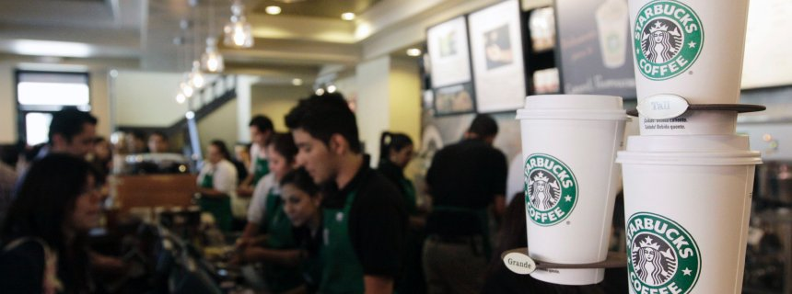
REUTERS
Is too much choice stressing us out?
Freedom is a good thing, isn't it? Not always, argues Slovenian philosopher Renata Salecl. The liberty to choose from an unlimited number of career options or coffee brands ultimately becomes a burden. Our modern capitalist society is ruled by a "tyranny of choice."
SPIEGEL ONLINE: Ms. Salecl, at the fast food chain Subway we have to make half a dozen decisions before we can finally enjoy our sandwich. Is that what you mean when you speak in your lectures about the "tyranny of choice?"
Salecl: I try to avoid places like Subway, and if I end up there I always order the same thing. When I speak about the "tyranny of choice," I mean an ideology that originates in the era of post-industrial capitalism. It began with the American Dream -- the idea of the self-made man, who works his way up from rags to riches. By and by, this career concept developed into a universal life philosophy. Today we believe we should be able to choose everything: the way we live, the way we look, even when it comes to the coffee we buy, we constantly need to weigh our decision. That is extremely unhealthy.
SPIEGEL ONLINE: Why?
Salecl: Because we constantly feel stressed, overwhelmed and guilty. Because, according to this ideology, it's our own fault if we're unhappy. It means we made a bad decision.
SPIEGEL ONLINE: And if we make the right choice?
Salecl: In that case, we constantly feel that there's something even better hiding behind the next corner. So we are never truly content and are reluctant to settle on anything.
SPIEGEL ONLINE: "Don't let the common man decide. He's not smart enough." That argument has been used by autocrats for centuries. Do you mean to say they are right?
Salecl: No. I don't criticize political or electoral freedom, but capitalism's perversion of the concept: the illusion that I hold the power over my own life.
SPIEGEL ONLINE: But I do have that power. I can decide for myself what I want, even if the thought stresses me out.
Salecl: Not at all. A friend, who's a psychologist, told me about a patient once: a woman who was well educated, had a good job, a house and a loving husband. "I did everything right in my life," said the woman. "But I'm still not happy." She never did what she herself wanted, but what she believed society expected from her.
SPIEGEL ONLINE: So we need to be better at pursuing our personal happiness?
Salecl: Even that is an illusion. Happiness has become a bar we measure ourselves against. The world is full of women's magazines that strive to tell us what will make us happy. It's filled with Facebook status updates, telling us how much other people are making of their lives. There are even indexes evaluating how happy certain nations are. "Be happy" has become a societal imperative. If you aren't, you have failed.
SPIEGEL ONLINE: But the motto also tells everyone that they can make their own choices. That gives people greater control over their lives.
Salecl: Yes, but that's only partially true. We still can't control the consequences our choices will bring. That's the next step. Not only do we want freedom of choice, but we also want a guarantee that whatever we choose will be exactly as we envisioned it.
SPIEGEL ONLINE: Why are we so afraid to just go with the flow?
Salecl: Because every time we decide for something, we lose something else. Buying a car is a great example. A lot of people not only read ratings before they buy their car but they continue afterwards -- to make sure they really made the right choice.
SPIEGEL ONLINE: If I have no choice, because I can't afford anything, will that make me happier?
Salecl: Paradoxically, no. One of the greatest gains of capitalism is that even the proletarian slave feels like a master. He believes he has the power to change his life. We are propelled by the ideology of the self-made man: we work more, we consume more and in the end we consume ourselves. The consequences are burnout, bulimia and other lifestyle diseases.
SPIEGEL ONLINE. Why do we treat ourselves so poorly?
Salecl: Sigmund Freud already discovered that suffering gives us pleasure -- in a strange masochistic way. The tyranny of choice exploits that weakness. Consumer culture exhausts us. We suffer. We destroy ourselves. And we just can't stop.
SPIEGEL ONLINE: But we aren't really the victims. After all, we created this system ourselves and as long as we keep consuming, it will continue to exist. Ultimately, capitalism only mirrors human nature.
Salecl: That's true. Freud also said we choose our own neuroses. Capitalism is the neurosis of humanity.
SPIEGEL ONLINE: There are other ways. There's a restaurant in London that only serves one dish and people are lining up outside to try it. And a company in Berlin sells T-Shirts without showing them to customers first.
Salecl: That's a clever marketing strategy. With children you can see the same thing. If you ask them at a movie theater what they want to see, they will likely be overwhelmed. On the other hand, if you say shortly before, "let's go see James Bond," they will probably say, "No, mommy, anything else, but not that." If there are no boundaries, we make our own.
SPIEGEL ONLINE: Will we ever be truly free?
Salecl: No. But we can live a more relaxed life. We can accept that our decisions aren't rational, that we are always conditioned by society; that we lose something every time we choose something else, and that we can't truly control the consequences of our decisions.
Interview Conducted by Stefan Schultz

http://www.economist.com/node/17723028

The tyranny of choice

You choose

If you can have everything in 57 varieties, making decisions becomes hard work
Dec 16th 2010 | PARIS | From the print edition

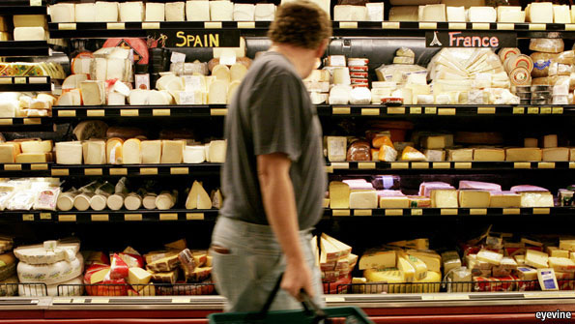
THESE are momentous times for the British potato crisp. Little over a generation ago the humble snack came in just a trio of flavours: ready salted, cheese and onion, or salt and vinegar. Today the choice is tongue-tingling: Thai sweet chilli, balsamic vinegar and caramelised onion, Oriental red curry, lime and coriander chutney, vintage cheddar and onion chutney, buffalo mozzarella and herbs, chicken tikka masala. And those are merely the varieties confected by a single crispmaker, Walkers, a division of PepsiCo, which turns out 10m bags of crisps every day for the British market alone. Venture towards the gourmet fringes of the crisp offering, and the choice and exoticism multiply: jalapeño pepper, roast ox, horseradish and sour cream, Ludlow sausage with wholegrain mustard. Crisps these days can be crinkle-cut, thick-cut, ridge-cut, square-cut, hand-fried, reduced fat, sold in six-packs, grab bags, party size or family packs.
Wheel a trolley down the aisle of any modern Western hypermarket, and the choice of all sorts is dazzling. The average American supermarket now carries 48,750 items, according to the Food Marketing Institute, more than five times the number in 1975. Britain's Tesco stocks 91 different shampoos, 93 varieties of toothpaste and 115 of household cleaner. Carrefour's hypermarket in the Paris suburb of Montesson, a hangar-like place filled with everything from mountain bikes to foie gras, is so vast that staff circulate on rollerblades.
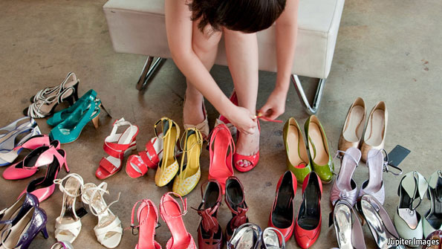
Choice seduces the modern consumer at every turn. Lattes come tall, short, skinny, decaf, flavoured, iced, spiced or frappé. Jeans come flared, bootlegged, skinny, cropped, straight, low-rise, bleach-rinsed, dark-washed or distressed. Moisturiser nourishes, lifts, smooths, revitalises, conditions, firms, refreshes and rejuvenates. Tropicana, another part of PepsiCo, turns out freshly pulped juice in more than 20 different varieties, up from just six in 2004; it says there could be as many as 30 in the next decade.
Thanks to a mix of modern medicine, technology and social change, choice has expanded from the grocery shelf to areas that once had few or none. Faces, noses, wrinkles, breasts and bellies can be remodelled, plumped or tucked. America in 2008 alone saw 2.5m Botox injections, 355,671 breast implants, 341,144 liposuction treatments, 195,104 eyelid lifts and 147,392 stomach tucks, according to the American Society for Aesthetic Plastic Surgery.
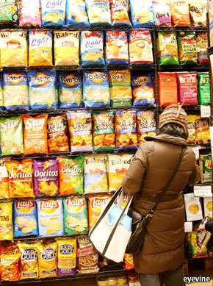
Teenagers can choose to surf, chat, tweet, zap or poke in ways that their parents can barely fathom. Moving pictures and music can be viewed, recorded, downloaded or streamed on all manner of screens or devices. The internet has handed huge power to the consumer to research options, whether of medical procedures or weekend breaks. Even the choice of price-comparison sites to help people choose is expanding.
Offline choices have multiplied too. European Union citizens can move, study, work and live wherever they like within the union. Vouchers and other school reforms in many countries give parents increasing choice over where to send their children. Modular university courses offer students endless combinations. The University of California, Berkeley, has over 350 degree programmes, including Buddhist Studies and Lesbian, Gay, Bisexual and Transgender Studies, each made up of scores of courses.
Choice has come to some of life's biggest personal decisions as well. In many countries couples can decide whether and where to marry, cohabit, divorce or remarry. Internet dating promises to find a match from a database of potential partners. Women in the rich world can choose when, and whether, to reproduce. “Do I want a baby? Will I find love again? Is this it?” screams the front cover of one recent women's magazine. Mothers (and sometimes fathers) can choose to work, or not, or take time off to raise children and then go back to their jobs. New life can be created against the odds. For sufferers from many chronic illnesses, life in old age can be prolonged—or ended.
Too much of a good thing
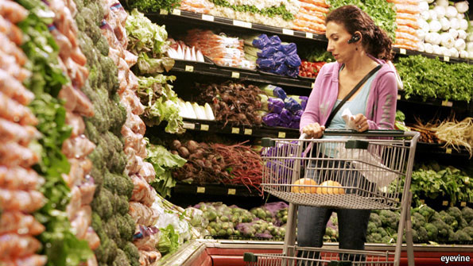
Many of these options have improved life immeasurably in the rich world, and to a lesser extent in poorer parts. They are testimony to human ingenuity and innovation. Free choice is the basis on which markets work, driving competition and generating economic growth. It is the cornerstone of liberal democracy. The 20th century bears the scars of too many failed experiments in which people had no choice. But amid all the dizzying possibilities, a nagging question lurks: is so much extra choice unambiguously a good thing?
Over the past decade behavioural scientists have come up with some intriguing insights. In one landmark experiment, conducted in an upmarket grocery store in California, researchers set up a sampling table with a display of jams. In the first test they offered a tempting array of 24 different jams to taste; on a different day they displayed just six. Shoppers who took part in the sampling were rewarded with a discount voucher to buy any jam of the same brand in the store. It turned out that more shoppers stopped at the display when there were 24 jams. But when it came to buying afterwards, fully 30% of those who stopped at the six-jam table went on to purchase a pot, against merely 3% of those who were faced with the selection of 24.
Expectations have been inflated to such an extent that people think the perfect choice exists
The researchers repeated the experiment with chocolate as well as student essay topics and found similar results. Too much choice, concluded Sheena Iyengar of Columbia University and Mark Lepper of Stanford, is demotivating. Others have since come up with similar results from experiments with writing pens, gift boxes, coffee and even American 401(k) pension plans. (It is not all that way: German researchers, by contrast, found that shoppers were not put off by too much choice, whether of jams, chocolates or jelly beans—though this may be down to Germany's price-conscious shoppers and the sheer dreariness of the country's supermarkets.)
As options multiply, there may be a point at which the effort required to obtain enough information to be able to distinguish sensibly between alternatives outweighs the benefit to the consumer of the extra choice. “At this point”, writes Barry Schwartz in “The Paradox of Choice”, “choice no longer liberates, but debilitates. It might even be said to tyrannise.” In other words, as Mr Schwartz puts it, “the fact that some choice is good doesn't necessarily mean that more choice is better.”
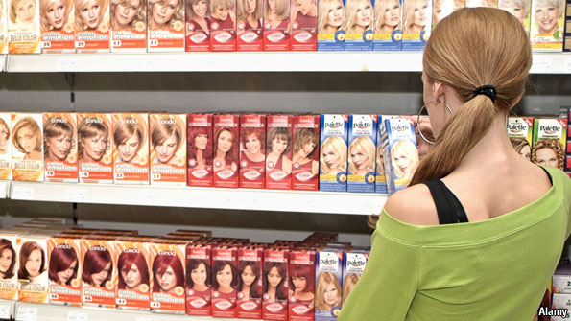
Daniel McFadden, an economist at the University of California, Berkeley, says that consumers find too many options troubling because of the “risk of misperception and miscalculation, of misunderstanding the available alternatives, of misreading one's own tastes, of yielding to a moment's whim and regretting it afterwards”, combined with “the stress of information acquisition”. Indeed, the expectation of indecision can prompt panic and a failure to choose at all. Too many options means too much effort to make a sensible decision: better to bury your head under a pillow, or have somebody else pick for you. The vast majority of shoppers in the Californian grocery store faced with 24 jam varieties simply chose not to buy any. The more expensive an item—a car, say—the more daunting the decision. As the French saying has it: “Trop de choix tue le choix” (too much choice kills the choice).
Surely, though, knowing that lots of choice is out there still feels good? The thrill is in the anticipation of falling upon the perfect Tuscan hotel, or shade of duck-egg blue with which to repaint the kitchen. Or the reassurance that competition to supply all that choice of electricity or telephony is keeping prices down and pushing service up. But not, according to psychologists, if more choice raises expectations too high, which may make even a good decision feel bad. The potential for regret about the options not taken—the faster car, the hotel with the better view—seems to be greater in the face of multiple choices.
Expectations have been inflated to such an extent that people think the perfect choice exists, argues Renata Salecl in her book “Choice”. Consider seduction. Bookshops are crowded with self-help guides and self-improvement manuals with titles such as “How to Choose & Keep Your Partner” or “Love is a Choice”. Internet dating sites promise to find the perfect match with just a few clicks of the mouse. This nourishes the hope of making the ideal choice, she says, as well as the fanciful idea that there are “quick, rational solutions to the complicated question of seduction”.
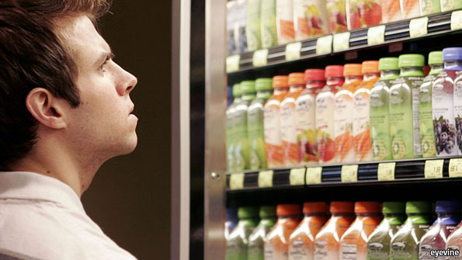
Confusion, indecision, panic, regret, anxiety: choice seems to come at a price. In one episode of “The Simpsons”, Marge takes Apu shopping in a new supermarket, Monstromart, whose cheery advertising slogan is “where shopping is a baffling ordeal”. “How is it”, muses Ms Salecl, “that in the developed world this increase in choice, through which we can supposedly customise our lives and make them perfect leads not to more satisfaction but rather to greater anxiety, and greater feelings of inadequacy and guilt?” A 2010 study by researchers at the University of Bristol found that 47% of respondents thought life was more confusing than it was ten years ago, and 42% reported lying awake at night trying to resolve problems.
It could be that today's children, growing up in a world of abundant choice, will find decisions even harder to take when they grow up. Their lives may be packed with instant choices as they zap from one site to another while texting a friend and listening to music on YouTube. But much of this is reflexive activity. The digital generation is doing what Mr Schwartz calls “picking”, not “choosing”: “With a world of choices rushing by like a music video,” he says, “all a picker can do is grab this or that and hope for the best.” Young people have grown up with masses of choice, says Dan O'Neil, a British life coach who helps people overcome indecision, “but they have never learned to make a choice and run with it. In adult life, they aren't equipped to cope.”

Following the crowd
Ever since the 19th century, when Levi Strauss began to stitch denim jeans for Americans and Abram Lyle started to sell tins of golden syrup to the English, brand managers have made it their business to offer shoppers an easier life. Brands simplify choices. They are a guarantee of quality or consistency in a confusing market, and a badge of trust. Companies spend heavily on marketing and legal advice to protect or reinvent their brands and keep customers loyal, exploiting customers' aversion to choice.
The more that options multiply, the more important brands become. Today, when paralysed by bewildering choice, a consumer will often turn to a brand that is cleverly marketed to appear to be one that others trust.
In Italo Calvino's novel “Mr Palomar”, the eponymous hero is dazzled by the mouth-watering variety of cheese he comes across at a fine Parisian fromagerie. “Mr Palomar's spirit vacillates between contrasting urges: the one that aims at complete, exhaustive knowledge and could be satisfied only by tasting all the varieties; and the one that tends toward an absolute choice, the identification of the cheese that is his alone,” writes Mr Calvino. In the end, “he stammers; he falls back on the most obvious, the most banal, the most advertised, as if the automatons of mass civilisation were waiting only for this moment of uncertainty on his part in order to seize him again and have him at their mercy.”
The anti-globalisation and green movements have stirred a consumer backlash against a surfeit of choice
Despite the crisp flavourologists' best efforts, there is a limit to how many packs can be stacked on a supermarket shelf. What of stuff that is distributed digitally, however, where choice is almost limitless? Technology has cut media distribution costs and made available a vast new array of material that caters to specialised or obscure tastes, in music, video or the written word. In this universe of proliferating choice, demand is said to be shifting from a few mass products (at the head of the distribution curve) towards a great many niche interests (at the tail end), as argued by Chris Anderson in “The Long Tail”.
It turns out, however, that despite the availability of all the extra stuff the hits are as important as ever. In 2009 there were 558 films released in America, up from 479 in 2000, not to mention the gigabytes of videos and film uploaded or shared online. Yet it was also the year in which one film, James Cameron's “Avatar”, broke all box-office records to become the highest-grossing film ever, beating the director's own 1997 blockbuster, “Titanic”. However many niches there are, in other words, film-goers or TV viewers still want to watch what everybody else is watching, and musicians still manage to release mega-hits. Indeed, in a world that celebrates individualism and freedom, many people decide to watch, wear or listen to exactly the same things as everybody else.

When less is more
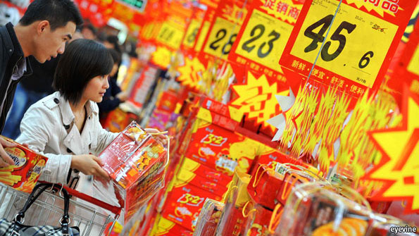
In small corners of the temples of consumption, business has begun to wake up to the perils of excess choice. Some firms employ “choice architects” to help guide consumers' decision-making and curb confusion. Tropicana's extra fruit-juice varieties boosted sales by 23% in Britain in 2009. But now the company puts colour-coded bottletops on sub-categories of juice to help customers “navigate what can be a difficult range”, says Patrick Kalotis, its marketing director in Britain. In “Nudge”, Richard Thaler and Cass Sunstein, two American academics, cite a study of company retirement plans. When a default option automatically selected an investment portfolio, saving employees the chore of picking their own mix of assets, participation shot up from 9% to 34%.
Some firms have pruned their ranges to avoid confusing shoppers. For example, Glidden, an American paint brand, decided in 2009 to reduce its palette of wall colours from an eye-dazzling 1,000 to a mere 282 because of a change in “Americans' priorities from ‘more is better' to ‘less is more'”. L'Astrance, a three-star Michelin restaurant in Paris's swanky 16th arrondissement, offers no choice at all on its menu: Pascal Barbot, the chef, concocts what he fancies from produce picked up in the market that day. And sometimes less really is more. When Procter & Gamble, an American consumer-products company, thinned its range of Head & Shoulders shampoos from 26 to 15, sales increased by 10%, according to Sheena Iyengar in “The Art of Choosing”.
“Traditionally, companies said that it's all about the customer, and therefore give them everything they want,” says Glen Williams of Bain, a consultancy. “In reality, this can make it difficult to identify which products the customer really wants, and can create problems for managing the business.” Offering too many jazzy options for new cars, say, may not only confuse consumers but add to production costs and increase the potential for factory-floor bungles. A 2006 Bain study suggested that reducing complexity and narrowing choice can boost revenues by 5-40% and cut costs by 10-35%.
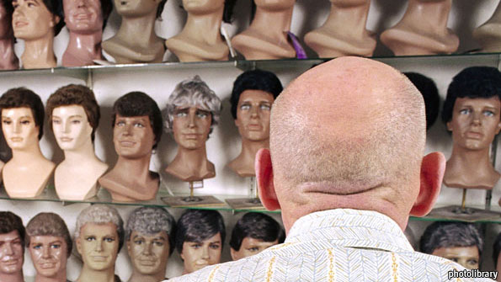
At the same time the anti-globalisation and green movements have stirred a consumer backlash against a surfeit of choice. Campaigns urge shoppers to buy locally grown fruit in season, and to shun cherries in winter or green beans flown in from Kenya. A “voluntary simplicity” movement calls on households to do away with excess consumer choice and lead a low-consumption, eco-friendly life. Courses promise to help people shed the distractions and stresses of the consumerist world and journey towards their inner wholeness. Short of turning the lawn over to organic vegetables and selling the car, books with such titles as “The Power of Less: The fine art of limiting yourself to the essential…in business and in life” or “Living Simply: Choosing less in a world of more” suggest practical ideas for cutting down on the effort of decision-making. The advice seems to boil down to shopping less often, keeping less stuff, watching less TV and sending fewer e-mails.
Life coaches offer to help with the perplexity of bigger choices. As recently as the early 1960s, in the world elegantly portrayed by a TV series, “Mad Men”, society gave both women and men far fewer options. Dealing with the strains and expectations of choice is today's payback. “At a certain age, my clients have this sudden realisation that life hasn't gone quite the way they intended, and they feel stuck,” says Mr O'Neil, who runs life-coaching classes. In the past they would have just got on with it. Today, he says, “they are paralysed by having too much choice.”
Fifty years after the contraceptive pill was first licensed in America and 37 years after the Supreme Court legalised abortion, women seem to agonise more than ever about breeding. “We've grown up with a lot more choice than our mothers or grandmothers; for them, being child-free wasn't a choice, it was pitied,” says Beth Follini, an American life coach who specialises in the “maybe baby” dilemma. “The anxiety comes from worrying about making the wrong choice.” Having options seems to make people think they can have control over outcomes too. Sometimes, says Ms Follini, choosing is about learning to live without control.
Those in the business of helping people choose offer various tips. Mr O'Neil says the key is taking a decision: “The truth is that it doesn't matter what we choose, only that we do choose.” Stick to the choices that matter and eliminate the rest, suggests one advocate of simple living, who supplies no fewer than 72 steps to choose from in order to simplify life. Another helpfully explains that “when you approach simple living, sometimes the decision is clear-cut. Sometimes it's not.” The trouble with simplifying your life, it turns out, is that it involves too many choices.
From the print edition: Christmas Specials

